**USER GUIDE FOR DENOVO GENOMICS PIPELINE**

**Content Page**

# 1: Introduction 2

# 2: Installation 2

# 2.1: Directory structure of DeNoGAP package.

# 2.2: System requirements.

# 2.3: List of required Perl modules and external programs for DeNoGAP.

# 2.4: Installation steps for DeNoGAP.

# 2.5: Installation of R and required R-libraries.

# 2.6: Installation and configuration of Apache webserver.

# 3: Input Data Files 8

# 3.1: Genome information file

# 3.2: Configuration files

# 4: SQLite database structure 19

# 5: Running DeNoGAP pipeline 26

# 6: Output directory structure. 30

# 7: Exploring output using DeNoGAP graphical user interface. 37

**1. Introduction**

Denovo Genomic Analysis Pipeline (DeNoGAP) is a software package for comparative analysis of multiple completed or draft genomes of prokaryotic species. The pipeline incorporates number of tools and databases for gene prediction, homolog prediction, ortholog prediction, functional annotation, phylogenetic profiling and core genome prediction.

**2. Installation**

The package for DeNoGAP is available at http://sourceforge.net/projects/denogap.

**2.1** **Directory structure of DeNoGAP package:**

**bin**: contain main-pipeline execution script, installation script, and other analysis scripts.

**config:** contain configuration files for defining parameters for different analysis phases.

**lib:**  contains DeNoGAP-specific Perl modules required for the analysis.

**exe:** directory to install external program by default.

**data**: directory to store input data files.

**doc:** contains manual for installing and using DeNoGAP.

**output:** directory to store output data / results.

**GUI:** contains cgi script and html file for graphical interface.

* **cgi-bin:** contains cgi scripts for connecting and accessing database using GUI.
* **html:** contains html page for graphical user interface to connect with the database.

**2.2 SYSTEM REQUIREMENT**

**Operating system: Linux**

**RAM: minimum 2GB**

The package provides a script (install.pl) to install necessary programs and Perl modules for performing analysis with DeNoGAP on Linux platform. Currently DeNoGAP has been only tested on Ubuntu Linux system. Although not tested for other operating systems, we assume that DeNoGAP can also run under other Unix based OS after installation of necessary programs and prerequisites. Windows OS user can use ‘cygwin’ to run DeNoGAP.

**2.3 List of required Perl modules / programs:**

**Perl modules:**

FindBin, Env, Exporter, Getopt::Long, File::Basename, File::Copy, Tie::File Parallel::ForkManager, List::MoreUtils, List::Util, File::Path, Hash::Merge, DBI, CGI, English, File::Spec::Functions, FileHandle, IO::Scalar, IO::String, Mail::Send, Sys::Hostname, URI::Escape, XML::Parser, XML::Quote, Statistics::Basic, Statistics::R, Sort::Fields

**BioPerl modules:**

Bio::Perl, Bio::SeqIO, Bio::Seq, Bio::SearchIO, Bio::Tools::Phylo::Phylip::ProtDist, Bio::AlignIO, Bio::SeqFeature::Generic, Bio::Annotation::Collection, Bio::Annotation::Comment

**R module:**

igraph

**External Programs:**

Muscle v3.8.31 or above (http://www.drive5.com/muscle)

Kalign2 (http://msa.sbc.su.se/downloads/kalign)

MCL (http://micans.org/mcl)

Hmmer version 3 or above (http://selab.janelia.org/software/hmmer3)

Phylip v3.6 or above (http://evolution.gs.washington.edu/phylip)

Glimmer (<http://ccb.jhu.edu/software/glimmer>)

Prodigal ([http://prodigal.googlecode.com](http://prodigal.googlecode.com/))

FragScan (<http://omics.informatics.indiana.edu/mg/get.php?software=FragGeneScan1.16.tar.gz>)

GeneMark ([http://opal.biology.gatech.edu](http://opal.biology.gatech.edu/))

InterProScan5 (<https://code.google.com/p/interproscan>)

EMBOSS ([http://emboss.sourceforge.net](http://emboss.sourceforge.net/))

SQLite ([https://sqlite.org](https://sqlite.org/))

R (<http://cran.r-project.org/mirrors.html>)

Apache ([http://www.apache.org](http://www.apache.org/))

**Note:** DeNoGAP provides Perl script to install necessary program. However, users can skip this step if all required program are pre-installed on their system with PATH environmental variable set for each program to be accessed by DeNoGAP.

In some cases, DeNoGAP may fail to set the PATH environmental variable for the program due to restricted permissions. Under such circumstances, user may want to manually set the path for each program on their system.

**We recommend users to check PATH for each external program prior to running analysis with DeNoGAP. We have list below examples for setting PATH for each external program. It may vary for users depending on the name of the source directory of each external program.**

Users can set path for each program by using putting following line in the “.bashrc” script.

**[MUSCLE]**

export PATH=$PATH:~userpath/DeNoGAP/exe/muscle

**[HMMER]**

export PATH=$PATH:~userpath/DeNoGAP/exe/ hmmer/bin

**[MCL]**

export PATH=$PATH:~userpath/DeNoGAP/exe/ mcl/bin

**[PHYLIP]**

export PATH=$PATH:~userpath/DeNoGAP/exe/ phylip/ phylip-3.695/exe

**[GLIMMER]**

export PATH=$PATH:~userpath/DeNoGAP/exe/ glimmer/glimmer3.02/bin

export PATH=$PATH:~userpath/DeNoGAP/exe/ glimmer/glimmer3.02/scripts

**[PRODIGAL]**

export PATH=$PATH:~userpath/DeNoGAP/exe/prodigal

**[FragGeneScan]**

export PATH=$PATH:~userpath/DeNoGAP/exe/ frag_gene_scan/FragGeneScan1.16

**[GeneMark]**

export PATH=$PATH:~userpath/DeNoGAP/exe/ genemark/genemark_suite_linux_64/gmsuite

**[BLAST]**

export PATH=$PATH:~userpath/DeNoGAP/exe/ blast/ncbi-blast-2.2.29+/bin

**[InterProScan]**

export PATH=$PATH:~userpath/DeNoGAP/exe/ interproscan/Interproscan-5.7-48.0

**2.4 STEP FOR INSTALLATION OF DeNoGAP:**

To install external programs using DeNoGAP install script, execute following command in the terminal:

**cd DeNoGAP**

**cd bin**

**perl install.pl**

Note: By default installation of most of the external programs will take place under “exe” directory of DeNoGAP package. However, some programs are installed under root directory by default, which requires administrative permissions from user for installation.

External Program installation script in DeNoGAP uses ftp URLs to download and install most up-to-date programs available till date. If users want to download any alternate version of any program, they can change the ftp URL for respective tool in the install script. Alternatively, they can manually install new version of the program.

**2.5 Installation of R and its libraries**

As there are many different version of R available on different mirror sites, DeNoGAP do not automatically install R on user system. However user on Ubuntu Linux can use following steps to install R and other necessary libraries.

Method 1:

**sudo apt-get install r-base**

This command will install basic R libraries on Ubuntu.

Method 2:

Download R version best suited for your system from <http://cran.r-project.org/mirrors.html> and follow instruction in source for installation.

Once installed, open command line terminal and perform following steps to install required libraries.

* **Type R on command line to open R command promt.**
* **install.packages(“igraph”)**
* **q()**

**2.6 Installation and Configuration of Apache web server for DeNoGAP**

DeNoGAP do not automatically install apache server. So please follow this steps to install apache on Ubuntu linux and configure it for GUI.

**sudo apt-get install apache2**

This will set up apache server on user system. Open any Web Browser window and type [http://localhost](http://localhost/) to test if apache is installed correctly or not. If installed correctly you should see a message on screen “It Works”.

By default the web document root for apache server is “**/var/www**”. You can set your own document root by making changes in configuration files as shown below.

Copy “**GUI/cgi-bin**” and “**GUI/html**” directories from DeNoGAP package to document root directory.

**Configuration of Apache Server for using GUI**

Perform steps below on command line to configure apache server on linux/Unix system:

* cd /etc/apache2
* cd sites-available
* sudo gedit default

This will open “default” file using gedit text editor. “**default**” is a virtual host file. We will make changes in this file to access GUI for DeNoGAP

Inside “**default**” file make following changes to default configuration.

1. Change line “**DocumentRoot /var/www**” to “**DocumentRoot /var/www/DeNoGAP/GUI**”.
2. Change line “**<Directory /var/www/>**” to “**<Directory /var/www/DeNoGAP/GUI>**”
3. In the same <Directory> </Directory> block, change “**Options Indexes FollowSymLinks MultiViews**” to “**Options Indexes FollowSymLinks MultiViews Includes ExecCGI**”
4. Add following line after <Directory> </Directory> block,

**Script Alias “/var/www/DeNoGAP/GUI/cgi-bin” /usr/lib/cgi-bin**

1. In the next <Directory> </Directory> block, Change **<Directory />** to **<Directory “/var/www/DeNoGAP/GUI/cgi-bin”**>
2. Add following line after the block,

**AddHandler cgi-script cgi pl**

1. Save and Close “**default**” file.

Create symbolic link in “**sites-enabled**” directory to an virtual-host file in “sites-available” directory using following command:

**sudo a2ensite default**

Restart Apache to read new configuration.

**sudo /etc/init.d/apache2 reload**

Open Web Browser and type [http://localhost](http://localhost/) to see web documents for DeNoGAP.

User should see two directories cg-bin and html. Instruction to use GUI is given in “**Exploration of database section**” below.

**3. Input Data Files**

DeNoGAP requires three input files to perform any analysis.

(1) The tab-delimited file containing metadata information about the genomes used for the analysis.

(2) The configuration file containing defined parameters for the analysis.

(3) SQLite Database file to store output.

The format and description for each input file is given below.

**3.1 Genome Information File**

The first line of the genome information file should start with “#” followed by tab-delimited column names. Remove any extra trailing spaces at the end of columns or line to avoid errors.

* **Mandatory Column names**
* **genome_name** : Full genome name.
* **species**: Full name of the species**.**
* **species_type:** specify if genome belongs to bacteria or archaea. (Acceptable values: bacteria / archaea)
* **abbreviation**: Short abbreviation for the genome. This will be used to identify and name all sequence files and output files. (Abbreviation should not have any dots or special characters except “_”).
* **genome_type:** Indicate if genome is a reference or query. (Acceptable values: reference / query).
* **outgroup:** Indicate if genome is an outgroup or not. (Acceptable values: Yes / No).
* **Optional Columns**
* Users can create any number of new columns to add any additional information to the genome information table.
* The name of additional columns should be in lower case without any special characters except “_”.

The example table is given in the data directory of DeNoGAP package.

**3.2 Configuration Files**

DeNoGAP uses separate configuration file for each analysis phase. All parameters, file paths, and directory paths required for performing the analysis should be defined in respective configuration file. Parameters are divided into different sections named within [] brackets. The optional parameters can be disabled if not in use by prefixing parameter name as “#-parameter name” in the configuration file. The description of each configuration file and parameters included in it is given below:

* **PARSE_GENBANK.config**

This configuration file defines parameters for extracting sequences and genomic information from the GenBank Files.

* **PARSE_GENBANK**: Initiates parsing of genebank files (Default value: YES).
* **GENBANK_DIR_PATH**: Define directory path for genebank files.
* **PROJECT_DIR_NAME**: Define name of the project directory. If not present, a new directory will be created with project name under main output directory. All result files and sub-directories will be created under project directory.
* **GENOME_DIR_NAME:** Sub-directory name to store fasta formatted genome sequence files.
* **CDS_DIR_NAME:** Sub-directory name to store fasta formatted coding sequence files.
* **PROTEIN_DIR_NAME:** Sub-directory name to store fasta formatted protein sequence files.
* **FEATURE_DIR_NAME:** Sub-directory name to store tab-delimited genomic feature files.
* **PREDICT_GENE.config**

This configuration file defines parameters to predict genes from the genome sequences using four gene prediction programs.

* **PREDICT_GENE:** Initiate gene prediction analysis. (Default value: YES).
* **GENOME_DIR_PATH:** Define directory path for fasta-formatted genome sequence files.
* **PROJECT_DIR_NAME:** Define name of the project directory. If not present, a new directory will be created with project name under main output directory. All result files and sub-directories will be created under project directory.
* **GILMMER_RESULT_DIR_NAME:** Sub-directory name to store glimmer output files.
* **GENEMARK_RESULT_DIR_NAME:** Sub-directory name to store GeneMark output files.
* **PRODIGAL_RESULT_DIR_NAME:** Sub-directory name to store prodigal output files.
* **FRAGSCAN_RESULT_DIR_NAME:** Sub-directory name to store fragscan output files.
* **CDS_DIR_NAME:** Sub-directory to store predicted coding sequence files.
* **PROTEIN_DIR_NAME:** Sub-directory to store translated protein sequence files.
* **FEATURE_DIR_NAME:** Sub-directory to store tab-delimited genomic feature files.
* **TRANSLATION_CODE:** Genebank codon table for translating coding sequences into proteins.
* **OVERLAP_BASE:** Number of overlapping bases allowed between adjacent genes.
* **PARALLEL_CPU_CORE:** Number of CPU core to be used for parallel processing.
* **GLIMMER3:** Define options for running glimmer3 program. Check available options from glimmer manual. All options should be defined within “ ”.
* **LONG_ORF:** Define options for running long-orfs program. Check available options from glimmer manual. All options should be defined within “ ”.
* **MULTI_EXTRACT:** Define options for running multi-extract program. Check available options from glimmer manual. All options should be defined within “ ”.
* **BUILD_ICM:** Define options for running build-icm program. Check available options from glimmer manual. All options should be defined within “ ”.
* **GMSN:** Define options for running GeneMark program. Check available options from GeneMark manual. DeNoGAP automatically takes value for “-- name” and “--species” options from the genome table. All other options should be defined here within “ ”.
* **PRODIGAL:** Define options for running Prodigal program. Check available options from prodigal help. DeNoGAP automatically takes value for -i , -t, -o, -a, -d , -s from the genome table. All other options should be defined here within “ ”.
* **FRAGSCAN:** Define options for running FragGeneScan program. Check available options from FragGeneScan help. DeNoGAP automatically takes value for “-genome” and “-out” options from the genome table. All other options should be defined here within “ ”.
* **GENE_VERIFICATION.config**

This configuration file defines parameters to verify and annotate predicted protein sequences by comparing sequence match within Uniprot database.

* **VERIFY_SEQUENCE:** Initiate verification of predicted protein sequences using Uniprot database. (Default Value: YES).
* **BLAST_ALIGNMENT_FILE:** Pairwise blast alignment result between protein sequences and UniPort database.
* **FEATURE_DIR:** Define full name of the directory including complete path containing genomic feature files.
* **CDS_DIR:** Define full name of the directory including complete path containing coding sequence files.
* **PROTEIN_DIR:** Define full name of the directory including complete path containing protein sequence files.
* **PROJECT_DIR_NAME:** Define name of the project directory. If not present, a new directory will be created with project name under main output directory. All result files and sub-directories will be created under project directory.
* **EVALUE_THRESHOLD:** Define minimum e-value cut-off for significant hits.
* **ALIGNMENT_IDENTITY:** Define minimum sequence identity for significant hits.
* **QUERY_COVERAGE:** Define minimum query coverage for significant match.
* **MIN_PROTEIN_LENGTH:** Define minimum protein sequence length cutoff to discard insignificant sequences.
* **LOAD_DATA.config**

This configuration file defines parameters to load sequences and genomic feature information in to the SQLite database.

* **LOAD_DATA:**  Initiate module for loading sequences and genomic data. (Default: YES).
* **FEATURE_DIR:** Define full name of the directory including complete path containing genomic feature files.
* **CDS_DIR:** Define full name of the directory including complete path containing coding sequence files.
* **PROTEIN_DIR:** Define full name of the directory including complete path containing protein sequence files.
* **ADJUST_HEADER:** Default value: YES. Adjust sequence identifier and format it as “genome_abbreviation|sequence_identifier”.
* **COMPARE_REFERENCE.config**

This configuration file defines parameter for pairwise sequence comparison between reference genomes using Phmmer program.

* **COMPARE_REFERENCE:** (Default value: YES). Initiates pairwise sequence comparison between reference genomes defined by user in genome table.
* **MODEL_DB:** Define name for the database file to be created for Hidden Markov models of the protein families. (Default value: HMM_MODEL_DB).
* **SEQ_DB:** Define name for the database file to be created for Singleton protein family sequences. (Default value: HMM_SEQ_DB).
* **PROJECT_DIR_NAME:** Define name of the project directory. If not present, a new directory will be created with project name under main output directory. All result files and sub-directories will be created under project directory.
* **HMMER_OPT:** Define options for running phmmer program. Check available options for phmmer from hmmer package manual. DeNoGAP automatically takes value for “-o” and “-domtblout” options from the genome table. All other options should be defined here within “ ”.
* **MAX_NUM_DOMAIN:** Define maximum number of hmmer domains allowed between matched sequences. (Default value: 5).
* **ACCURACY_THRESHOLD:** Define hmmer accuracy probability cutoff for significant match. The value range is between [0 - 1]. (Default value: 0.8)
* **IDENTITY:** Define percentage identity cutoff for significant match. (Default value: 70).
* **SIMILARITY:** Define percentage similarity cutoff for significant match. (Default value: 60).
* **QUERY_COVERAGE:** Define percentage cutoff for query sequence covered in a significant match. (Default value: 70).
* **HMM_COVERAGE:** Define percentage cutoff for hmm model sequence covered in a significant match. (Default value: 70).
* **MIN_CHIMERA_IDENTITY:** Define percentage identity cutoff for predicting chimera-like match. (Default value: 70)
* **MIN_CHIMERA_SIMILARITY:** Define percentage similarity cutoff for predicting chimera-like match. (Default value: 60)
* **MIN_CHIMERA_QUERY_COVERAGE:**  Define percentage cutoff for query sequence covered in a chimera match. (Default value: 25).
* **MIN_CHIMERA_HMM_COVERAGE:** Define percentage cutoff for hmm model sequence covered in a chimera match. (Default value: 25).
* **PARALLEL_CPU_CORE:** Define number of CPU cores to be used for the analysis. (Default value: 1).
* **MCL_INFLATION_VALUE:** Define inflation vaule (I) for MCL clustering. (Default value: 1.5).
* **PREDICT_HMM_FAMILY.config**

This configuration files define parameters for iterative prediction of protein families in additional genomes.

* **PREDICT_HMM:** Initiate iterative comparison of protein sequences from new genomes. (Default value: YES).
* **MODEL_DB:** Define name for the database file to be created for Hidden Markov models of the protein families. (Default value: HMM_MODEL_DB).
* **SEQ_DB:** Define name for the database file to be created for Singleton protein family sequences. (Default value: HMM_SEQ_DB).
* **HMM_CLUSTER_FILE:** Define complete path and file name of the seed family cluster file.
* **MODEL_DB_FILE (optional):** Define complete path and file name of the seed HMM model database file. If this option is disable, DeNoGAP first calculates hmm model for all families in the existing cluster file.
* **SINGLETON_DB_FILE (optional):** Define complete path and file name of the seed Singleton sequence database file. If this option is disable, DeNoGAP first calculates singleton sequence for all families in the existing cluster file.
* **PROJECT_DIR_NAME:** Define name of the project directory. If not present, a new directory will be created with project name under main output directory. All result files and sub-directories will be created under project directory.
* **HMMER_OPT:** Define options for running hmmscan and phmmer program. Check available options for hmmscan and phmmer from hmmer package manual. DeNoGAP automatically takes value for “-o” and “-domtblout” options from the genome table. All other options should be defined here within “ ”.
* **MAX_NUM_DOMAIN:** Define maximum number of hmmer domains allowed between matched sequences. (Default value: 5).
* **ACCURACY_THRESHOLD:** Define hmmer accuracy probability cutoff for significant match. The value range is between [0 - 1]. (Default value: 0.8)
* **IDENTITY:** Define percentage identity cutoff for significant match. (Default value: 70).
* **SIMILARITY:** Define percentage similarity cutoff for significant match. (Default value: 60).
* **QUERY_COVERAGE:** Define percentage cutoff for query sequence covered in a significant match. (Default value: 70).
* **HMM_COVERAGE:** Define percentage cutoff for hmm model sequence covered in a significant match. (Default value: 70).
* **MIN_CHIMERA_IDENTITY:** Define percentage identity cutoff for predicting chimera-like match. (Default value: 70)
* **MIN_CHIMERA_SIMILARITY:** Define percentage similarity cutoff for predicting chimera-like match. (Default value: 60)
* **MIN_CHIMERA_QUERY_COVERAGE:**  Define percentage cutoff for query sequence covered in a chimera match. (Default value: 25).
* **MIN_CHIMERA_HMM_COVERAGE:** Define percentage cutoff for hmm model sequence covered in a chimera match. (Default value: 25).
* **PARALLEL_CPU_CORE:** Define number of CPU cores to be used for the analysis. (Default value: 1).
* **MCL_INFLATION_VALUE:** Define inflation vaule (I) for MCL clustering. (Default value: 1.5).
* **PREDICT_SUPER_HOMOLOG.config**

This configuration file defines parameters for predicting super-homolog family and identifying links between partial gene families and full-length gene families.

* **PREDICT_SUPER_HOMOLOG:** Initiate prediction of super-homolog families (Default value: YES).
* **HMM_CLUSTER_FILE:** Define complete path and file name of the hmm-family cluster file.
* **OLD_HOMOLOG_DATABASE_FILE (optional)**: Define complete path and file name of existing homolog database file. If value for this parameter is defined, DeNoGAP will use homolog cluster information from this database to append members from new genome to existing homolog families. If you don’t want to use this parameter. Insert “#:” symbol before the parameter name to disable it.
* **IDENTITY_THRESHOLD:** Define percentage identity cutoff for significant partial match. (Default value: 70).
* **SIMILARITY_THRESHOLD:** Define percentage similarity cutoff for significant partial match. (Default value: 60).
* **QUERY_COVERAGE_THRESHOLD:** Define percentage cutoff for query sequence covered in a significant partial match. (Default value: 70).
* **SUBJECT_COVERAGE_THRESHOLD:** Define percentage cutoff for subject sequence covered in a significant partial match. (Default value: 70).
* **PROJECT_DIR_NAME:** Define name of the project directory. If not present, a new directory will be created with project name under main output directory. All result files and sub-directories will be created under project directory.
* **PREDICT_ORTHOLOG.config**

This configuration file defines parameters for predicting ortholog and inparalog protein pairs and cluster ortholog families.

* **PREDICT_ORTHOLOG**: Initiate prediction of ortholog and in paralog pairs. (Default value: YES).
* **CLUSTER_ORTHOLOG**: Initiate clustering of ortholog and inparalog pairs. (Default value: YES).
* **HMM_CLUSTER_FILE:** Define complete path and file name of the hmm-family cluster file.
* **HOMOLOG_CLUSTER_FILE:** Define complete path and file name of super-homolog cluster file.
* **OLD_ORTHOLOG_DATABASE_FILE (optional):** Define complete path and file name of existing ortholog database. If value for this parameter is provided, DeNoGAP will only compute ortholog and paralog pair in new added genomes and append new information to the existing data.
* **PROJECT_DIR_NAME:** Define name of the project directory. If not present, a new directory will be created with project name under main output directory. All result files and sub-directories will be created under project directory.
* **ORTHOLOG_DIVERGENCE_THRESHOLD:** Define distance cut-off between [0 – 10] for predicting ortholog pairs in case out-group is absent. Less than 1 indicates similar sequences and greater than 1 indicates divergent sequences (Default value: 0.8).
* **INPARALOG_DIVERGENCE_THRESHOLD:** Define distance cut-off between [0 – 10] for predicting inparalog pairs in case out-group is absent. Less than 1 indicates similar sequences and greater than 1 indicates divergent sequences (Default value: 0.5).
* **GLOBAL_ALIGNMENT_OVERLAP_THRESHOLD:** Define sequence overlap cut-off between [0 – 1] for each pair of sequences in global alignment of homolog family. 0 indicates no overlap between sequences and 1 indicates complete overlap between sequences.
* **PAIRWISE_SEQUENCE_IDENTITY_THRESHOLD:** Define identity cut-off between [0 – 100] for each pair of sequences in a homolog family. 0 indicates no identity at all between sequences and 100 indicates completely identical sequences.
* **PAIRWISE_SEQUENCE_SIMILARITY_THRESHOLD:** Define similarity cut-off between [0 – 100] for each pair of sequences in a homolog family. 0 indicates no similarity at all between sequences and 100 indicates highly similar sequences.
* **MCL_INFLATION_VALUE:** Define inflation vaule (I) for MCL clustering. (Default value: 1.5).
* **PARALLEL_CPU_CORE:** Define number of CPU cores to be used for the analysis. (Default value: 1).
* **PHYLOGENETIC_PROFILE.config**

This configuration file generates a phylogenetic profile matrix to represent presence or absence of protein families across genomes.

* **PHYLOGENETIC_PROFILE:** Initiate analysis for making binary Phylogenetic profile. (Default value: YES).
* **ORTHOLOG_CLUSTER_FILE:** Define complete path and name of the protein family cluster file.
* **ORTHOLOG_DATABASE_FILE:** Define complete path and name of the ortholog database file for storing phylogenetic profile matrix.
* **PROJECT_DIR_NAME:** Define name of the project directory. If not present, a new directory will be created with project name under main output directory. All result files and sub-directories will be created under project directory.
* **CORE_GENOME.config**

This configuration file defines parameters for predicting core protein families and create concatenated core-genome alignment.

* **CORE_GENOME:** Initiate analysis for predicting core-genome. (Default value: YES).
* **ORTHOLOG_CLUSTER_FILE:** Define complete path and name of the protein family cluster file.
* **ORTHOLOG_DATABASE_FILE:** Define complete path and name of the ortholog database file.
* **CORE_ALIGNMENT_FILE:** Define complete path and name of the concatenated core alignment file.
* **CORE_THRESHOLD:** Define minimum percentage of required genome for predicting core-genome.
* **SEQUENCE_TYPE:** Define sequence type (Options: nucleotide / protein). (Default value: protein).
* **INCLUDE_OUTGROUP:** Include out-group sequences in core genome alignment. (Default value: NO).
* **PROJECT_DIR_NAME:** Define name of the project directory. If not present, a new directory will be created with project name under main output directory. All result files and sub-directories will be created under project directory.
* **ANNOTATION.config**

This configuration files defines parameters for predicting functional annotation for protein sequences using InterProScan.

* **PREDICT_ANNOTATION:** Initiates annotation of protein sequences. (Default value: YES).
* **INTERPRO_SCAN_PATH:** Define source directory path for interproscan databases and files.
* **INTERPRO_SCAN_OPTS:** Define options for running interproscan analysis. Check available options from InterProscan help. DeNoGAP automatically takes value for “-i”, “-f” and “-o” options from the genome table. All other options should be defined here within “ ”.
* **PROJECT_DIR_NAME:** Define name of the project directory. If not present, a new directory will be created with project name under main output directory. All result files and sub-directories will be created under project directory.
* **PARALLEL_CPU_CORE:** Define number of CPU cores to be used for the analysis. (Default value: 1).

**4. SQLite Database Schema**

DeNoGAP uses SQLite database to store analyzed information. DeNoGAP creates 3 databases: Master database, Homolog database and Ortholog database with total 20 tables to store results from various analysis phases. The description of each table and their columns is given below:

**(I) Master Database:**

|  |  |  |
| --- | --- | --- |
| **Table: OrganismInfo** | | |
| **Column** | **Data type** | **Description** |
| genome_name | TEXT | Full name of the genome |
| species | TEXT | Full name of the species |
| genome_abbreviation | TEXT | short name for the genome |
| genome_type | TEXT | Is Reference or Query |
| outgroup | TEXT | Is outgroup or not |

|  |  |  |
| --- | --- | --- |
| **Table: GeneFeature** | | |
| **Column** | **Data type** | **Description** |
| feature_id | TEXT | Unique sequence identifier for the gene |
| feature_type | TEXT | By default: CDS |
| protein_id | TEXT | Unique protein sequence identifier. |
| dbxref | TEXT | External database identifier for gene or protein. |
| genome_id | TEXT | Unique sequence identifier for the genome sequence |
| genome_type | TEXT | Chromosome / Plasmid / Contig |
| genome_name | TEXT | Full name of the genome |
| genome_length | INT | Length of the genome sequence |
| feature_start | INT | Start co-ordinate of the gene sequence |
| feature_end | INT | End co-ordinate of the gene sequence |
| nuc_length | INT | Length of the coding sequence |
| aa_length | INT | Length of the protein sequence |
| strand | INT | Genome strand on which gene is located ( + or -) |
| frame | INT | Coding frame for the coding sequence |
| index_on_genome | INT | Order on the genome sequence |
| description | TEXT | Product description |
| comment | TEXT | Comment by user |

|  |  |  |
| --- | --- | --- |
| **Table: ProteinSequence** | | |
| **Column** | **Data type** | **Description** |
| pseq_index_id | INT | Auto-incremented primary key index |
| protein_id | TEXT | Unique sequence identifier for protein |
| genome_abbreviation | TEXT | Short name for the genome |
| seq_type | TEXT | Protein |
| seq_length | INT | Length of amino acid sequence |
| aa_sequence | TEXT | Protein sequence |

|  |  |  |
| --- | --- | --- |
| **Table: NucleotideSequence** | | |
| **Column** | **Data type** | **Description** |
| nseq_index_id | INT | Auto-incremented primary key index |
| nucleotide_id | TEXT | Unique sequence identifier for CDS |
| genome_abbreviation | TEXT | Short name for the genome |
| seq_type | TEXT | Protein |
| seq_length | INT | Length of coding sequence sequence |
| nuc_sequence | TEXT | CDS sequence |

|  |  |  |
| --- | --- | --- |
| **Table: Similarity** | | |
| **Column** | **Data type** | **Description** |
| query_id | TEXT | Sequence identifier for the query protein |
| subject_id | TEXT | Identifier for the target sequence or target hmm group |
| query_length | INT | Length of query sequence |
| subject_length | INT | Length of target sequence or target hmm model |
| num_total_domain | INT | Total domains predicted in the query sequence |
| num_significant_domain | INT | Number of domains with significant match |
| query_start | INT | Start position of query sequence |
| query_end | INT | End position of query sequence |
| subject_start | INT | Start position of the target |
| subject_end | INT | End position of the target |
| evalue | REAL | Significance value |
| bit_score | INT | Bit score of the alignment |
| percent_identity | REAL | Percentage identity between sequences |
| percent_similarity | REAL | Percentage similarity between sequences |
| query_coverage | REAL | Percentage query sequence coverage |
| subject_coverage | REAL | Percentage target sequence coverage |
| pair_relation | TEXT | Match type (best / truncated / chimera / insignificant) |

|  |  |  |
| --- | --- | --- |
| **Table: DomainAnnotation** | | |
| **Column** | **Data type** | **Description** |
| protein_id | TEXT | Unique sequence identifier |
| genome_name | TEXT | Genome abbreviation |
| seq_len | INT | Length of query sequence |
| domain_id | TEXT | Unique identifier for the predicted domain |
| domain_name | TEXT | Name of the predicted domain |
| domain_start | INT | Start position of the domain |
| domain_end | INT | End position of the domain |
| significance_value | REAL | Significance of the domain match |
| description | TEXT | Domain description |

|  |  |  |
| --- | --- | --- |
| **Table: InterProAnnotation** | | |
| **Column** | **Data type** | **Description** |
| protein_id | TEXT | Unique sequence identifier |
| genome_name | TEXT | Genome abbreviation |
| interpro_id | TEXT | Unique identifier for the interpro domain |
| interpro_name | TEXT | Name of the predicted interpro domain |

|  |  |  |
| --- | --- | --- |
| **Table: GOAnnotation** | | |
| **Column** | **Data type** | **Description** |
| protein_id | TEXT | Unique sequence identifier |
| genome_name | TEXT | Genome abbreviation |
| go_id | TEXT | Unique identifier for the gene ontology term |
| go_category | TEXT | Classification category for go term |
| go_description | TEXT | Description of the go term |

|  |  |  |
| --- | --- | --- |
| **Table: PathwayAnnotation** | | |
| **Column** | **Data type** | **Description** |
| protein_id | TEXT | Unique sequence identifier |
| genome_name | TEXT | Genome abbreviation |
| pathway_id | TEXT | Unique identifier for the predicted pathway |
| pathway_name | TEXT | Name of the predicted pathway |

|  |  |  |
| --- | --- | --- |
| **Table: SignalPAnnotation** | | |
| **Column** | **Data type** | **Description** |
| protein_id | TEXT | Unique sequence identifier |
| genome_name | TEXT | Genome abbreviation |
| domain_start | REAL | Start position of signal peptide |
| domain_end | REAL | End position of signal peptide |

|  |  |  |
| --- | --- | --- |
| **Table: TMHMMAnnotation** | | |
| **Column** | **Data type** | **Description** |
| protein_id | TEXT | Unique sequence identifier |
| genome_name | TEXT | Genome abbreviation |
| domain_start | REAL | Start position of transmembrane |
| domain_end | REAL | End position of transmembrane |

|  |  |  |
| --- | --- | --- |
| **Table: PhobiusAnnotation** | | |
| **Column** | **Data type** | **Description** |
| protein_id | TEXT | Unique sequence identifier |
| genome_name | TEXT | Genome abbreviation |
| domain_name | TEXT | Name of domain |
| domain_description | TEXT | Description of domain |
| domain_start | REAL | Start position of domain |
| domain_end | REAL | End position of domain |

**(II) Homolog Database:**

|  |  |  |
| --- | --- | --- |
| **Table: LinkFamily** | | |
| **Column** | **Data type** | **Description** |
| family_idA | TEXT | Group id of hmm family |
| family_idB | TEXT | Group id of hmm family |
| significance | REAL | Significance value between pair |

|  |  |  |
| --- | --- | --- |
| **Table: GenetoSuperFamily** | | |
| **Column** | **Data type** | **Description** |
| gene_superfamily_index_id | INT | Auto increment primary key index |
| gene_id | TEXT | Unique sequence identifier |
| genome_name | TEXT | Genome abbreviation |
| hmm_family_id | TEXT | Hmm family identifier |
| super_family_id | TEXT | Super-homolog family identifier |

**(III) Ortholog Database:**

|  |  |  |
| --- | --- | --- |
| **Table: MultipleAlignment** | | |
| **Column** | **Data type** | **Description** |
| seq_id | TEXT | Unique sequence identifier |
| genome_abbreviation | TEXT | Genome abbreviation |
| seq_type | TEXT | Genome abbreviation |
| alignment_id | TEXT | Super-homolog family identifier |
| alignment_length | INT | Length of super-homolog alignment |
| alignment_sequence | TEXT | Aligned sequence |

|  |  |  |
| --- | --- | --- |
| **Table: DistancePair** | | |
| **Column** | **Data type** | **Description** |
| taxonA | TEXT | Genome abbreviation for SeqA |
| idA | TEXT | Unique sequence identifier SeqA |
| taxonB | TEXT | Genome abbreviation for SeqB |
| idB | TEXT | Unique sequence identifier SeqB |
| divergence | REAL | Pairwise distance between SeqA and SeqB |
| homolog_cluster_id | TEXT | Super-homolog family identifier |

|  |  |  |
| --- | --- | --- |
| **Table: OrthologPair** | | |
| **Column** | **Data type** | **Description** |
| taxonA | TEXT | Genome abbreviation for SeqA |
| idA | TEXT | Unique sequence identifier SeqA |
| taxonB | TEXT | Genome abbreviation for SeqB |
| idB | TEXT | Unique sequence identifier SeqB |
| divergence | REAL | Pairwise distance between SeqA and SeqB |
| homolog_cluster_id | TEXT | Super-homolog family identifier |

|  |  |  |
| --- | --- | --- |
| **Table: InParalogPair** | | |
| **Column** | **Data type** | **Description** |
| taxonA | TEXT | Genome abbreviation for SeqA |
| idA | TEXT | Unique sequence identifier SeqA |
| taxonB | TEXT | Genome abbreviation for SeqB |
| idB | TEXT | Unique sequence identifier SeqB |
| divergence | REAL | Pairwise distance between SeqA and SeqB |
| min_ortholog_divergence | REAL | Minimum pairwise distance between SeqA and ortholog from any other genome. |
| homolog_cluster_id | TEXT | Super-homolog family identifier |

|  |  |  |
| --- | --- | --- |
| **Table: PairwiseAlignment** | | |
| **Column** | **Data type** | **Description** |
| idA | TEXT | Unique sequence identifier SeqA |
| idB | TEXT | Unique sequence identifier SeqB |
| sequence_identity | REAL | Pairwise identity between idA and idB |
| sequence_similarity | REAL | Pairwise similarity between idA and idB |
| homolog_cluster_id | TEXT | Super-homolog family identifier |

|  |  |  |
| --- | --- | --- |
| **Table: PhylogeneticProfile** | | |
| **Column** | **Data type** | **Description** |
| id | TEXT | Ortholog family id |
| genome_name | TEXT | Genome abbreviation |

|  |  |  |
| --- | --- | --- |
| **Table: MapGeneIdtoGeneFamily** | | |
| **Column** | **Data type** | **Description** |
| familymap_index_id | INT | Auto-incremented primary key index |
| genefamily_id | TEXT | Unique identifier for predicted ortholog family |
| gene_id | TEXT | Unique identifier for the sequence |
| specie_abbreviation | TEXT | Genome abbreviation |

**5. Running DeNoGAP commands**

In order to run analysis using DeNoGAP execute commands shown below.

**cd DeNoGap_v1.0**

**cd bin**

perl Denogap_v1.0.pl -**genome_info** <genome information file> -**db_dir** <full path sqlite database dir path> **-db_name** <name of the master sqlite database> **-config** <full path and name of configuration file> **-output_dir** <full path and name to the output directory>

**Running DeNoGAP with test dataset**

The package contains 2 dataset that are under **data/test1** and **data/test2** directories.

The data/test1 contains input files to initiate new analysis with new set of genomes.

The data/test2 contains input files to add new genomes to the existing analysis database.

**Note 1**: Sometimes copying command directly from documentation file and pasting in terminal window may cause errors. If so, please type the command in terminal as shown below.

**Note 2:** Replace ~userpath with path to DeNoGAP directory as per the user’s directory path.

* **Test parse genbank files**

**perl DeNoGap_v1.0.pl -genome_info ../data/test1/test_genome_table_1.txt -db_dir ../output/TEST_RUN –db_name test.sqlite -config ../config/PARSE_GENBANK.config –output_dir ../output/TEST_RUN**

This command will parse genebank file given as input and extract genomic information including (Genome Sequences, CDS, Proteins, Genomic coordinates and annotation). The sequences will be stored in FASTA format and Genomic feature information will be stored in tab-delimited and GFF file formats.

* **Test gene prediction**

**perl DeNoGap_v1.0.pl -genome_info ../data/test1/test_genome_table_1.txt –db_dir ../output/TEST_RUN –db_name test.sqlite –config ../config/PREDICT_GENE.config –output_dir ../output/TEST_RUN**

This command will run four different gene prediction algorithms (Glimmer, GeneMark, Prodigal and FragGeneScan) on each genome sequence to predict potential ORFs. The raw results obtained by running each algorithm and processed results after predicting ORFs using DeNoGAP will be stored in output directory. The sequences will be stored in Fasta Format, and Genomic features will be stored in tab-delimited, GFF and Genebank format.

* **Test gene verification and annotation**

- Download and extract UniProt database.

(<ftp://ftp.uniprot.org/pub/databases/uniprot/current_release/knowledgebase/complete/uniprot_sprot.fasta.gz>)

* Perform protein Blast with all predicted sequences against Uniprot database and store output in default format (**-outfmt 0**). BLAST parameters shown here are just for an example.

**blastp –query <predicted_sequence_file> -db <Uniprot_database_file> -evalue 1e-05 –out <blast_output_file> -max_target_seq 1**

* Perform gene verification and annotation analysis using DeNoGAP.

**perl DeNoGap_v1.0.pl -genome_info ../data/test1/test_genome_table_1.txt –db_dir ../output/TEST_RUN –db_name test.sqlite –config ../config/GENE_VERIFICATION.config –output_dir ../output/TEST_RUN**

This command will check predicted genes and proteins based on user-defined thresholds. Sequence and genomic feature information for verified genes will be stored in output directory.

* **Test Load Data**

**perl DeNoGap_v1.0.pl -genome_info ../data/test1/test_genome_table_1.txt –db_dir ../output/TEST_RUN –db_name test.sqlite –config ../config/LOAD_DATA.config –output_dir ../output/TEST_RUN**

This command will load Sequence and genomic feature information into the Master Sqlite database for DeNoGAP analysis.

* **Test Reference comparision**

**perl DeNoGap_v1.0.pl -genome_info ../data/test1/test_genome_table_1.txt –db_dir ../output/TEST_RUN –db_name test.sqlite –config ../config/COMPARE_REFERENCE.config –output_dir ../output/TEST_RUN**

This step will run pairwise sequence comparison for reference protein sequences and store results in master sqlite database. The database for HMM models and singleton sequences will be saved in HOMOLOG_SCAN/RESULT directory. The predicted reference HMM model cluster file will be also stored in HOMOLOG_SCAN/RESULT directory.

* **Test Iterative HMM family prediction**

**perl DeNoGap_v1.0.pl -genome_info ../data/test1/test_genome_table_1.txt –db_dir ../output/TEST_RUN –db_name test.sqlite –config ../config/PREDICT_HMM.config –output_dir ../output/TEST_RUN**

This steps takes HMM model DB, Singleton model DB and Reference HMM model cluster files defined in PREDICT_HMM.config file as input to iteratively predict HMM families in new genomes. The name of the master sqlite database given as input using command line parameter “–db_name” should be same as name given for reference family construction. The predicted HMM model cluster file will be also stored in HOMOLOG_SCAN/RESULT directory.

* **Test homolog family prediction**

**perl DeNoGap_v1.0.pl -genome_info ../data/test1/test_genome_table_1.txt –db_dir ../output/TEST_RUN –db_name test.sqlite –config ../config/PREDICT_SUPER_HOMOLOG.config –output_dir ../output/TEST_RUN**

This command identifies HMM models that are partially similar and group HMM families together into larger homolog family. Running this command will create new database in “–db_dir” directory with name **HomologDB_<Day_Month_Date_Hour_Min_Sec_Year>.**

If you want to use homolog database from previous analysis run and only predict homolog families for new added genomes. Then edit PREDICT_SUPER_HOMOLOG.config file and provide full path and name for previous Homolog database file in the parameter “OLD_HOMOLOG_DATABASE_FILE”. This will allow DeNoGAP to use homolog group information for previously analyzed genomes. **Note: HomologDB_<Day_Month_Date_Hour_Min_Sec_Year> is appended with all information stored in “OLD_HOMOLOG_DATABASE_FILE”.**

* **Test Ortholog Prediction and Ortholog Clustering**

perl DeNoGap_v1.0.pl -genome_info ../data/test1/test_genome_table_1.txt –db_dir ../output/TEST_RUN –db_name test.sqlite –config ../config/PREDICT_ORTHOLOG.config –output_dir ../output/TEST_RUN

This command runs ortholog prediction for each homolog family and stores results in HOMOLOG_SCAN/ORTHOLOG directory and **OrthologDB_<Day_Month_Date_Hour_Min_Sec_Year>.**

If you want to use ortholog database from previous analysis run and only predict ortholog families for new added genomes. Then edit PREDICT_ORTHOLOG.config file and provide full path and name for previous ortholog database file in the parameter “OLD_ORTHOLOG_DATABASE_FILE”. This will allow DeNoGAP to use ortholog group information for previously analyzed genomes. **Note: OrthologDB_<Day_Month_Date_Hour_Min_Sec_Year> is appended with all information stored in “OLD_ORTHOLOG_DATABASE_FILE”.**

* **Test Phylogenetic profile**

perl DeNoGap_v1.0.pl -genome_info ../data/test1/test_genome_table_1.txt –db_dir ../output/TEST_RUN –db_name test.sqlite –config ../config/PHYLOGENETIC_PROFILE.config –output_dir ../output/TEST_RUN

This command builds phylogenetic profile with (1) and (0) indicating presence and absence of gene families in each genome. The profile is stored in output directory and master sqlite database as a matrix and table.

* **Test Core genome prediction**

perl DeNoGap_v1.0.pl -genome_info ../data/test1/test_genome_table_1.txt –db_dir ../output/TEST_RUN –db_name test.sqlite –config ../config/CORE_GENOME.config -output_dir ../output/TEST_RUN

This command builds concatenated core genome alignment for predicted core genes. The alignment is stored in the output directory.

* **Test Function Annotation prediction**

perl DeNoGap_v1.0.pl -genome_info ../data/test1/test_genome_table_1.txt –db_dir ../output/TEST_RUN –db_name test.sqlite –config ../config/ANNOTATION.config -output_dir ../output/TEST_RUN

This command performs annotation of each protein sequence using InterProScan. The result of annotation is stored in master sqlite database and output directory.

**6. Output Directory Structure**

This section gives an overview of the output directory structure and output files created for each analysis phase.

**Database directory:** Users should define the name and path of database directory.

**Database name:** User should define the name of the master SQLite database file.

**Analysis: Parse GenBank**

The output directory for parsed genbank files contains four sub-directories defined in the configuration file.

* **GENEBANK_DATA**
* **Genome sequence directory**: This directory contains fasta formatted genome sequence files (one file for each organism).
* **Coding sequence directory**: This directory contains fasta formatted coding gene sequences (one file for each organism).
* **Protein sequence directory**: This directory contains fasta formatted protein sequences (one file for each organism).
* **Genomic feature directory**: This directory contains tab-delimited genomic feature files (one file for each organism).
* **GFF file directory**: This directory contains GFF formated genomic feature files (one file for each organism).

**Format of Fasta Files**

>PSPTO_0001 product=Chromosomal replication initiator protein DnaA chromosome=NC_004578 strand=1 codon_start=1 coordinates=339..1874 [Pseudomonas syringae pv. tomato DC3000]

*

**Format of Gene Feature File**

**#feature_id feature_type protein_id dbxref genome_id genome_type genome_name genome_length feature_start feature_end nuc_lenth aa_length strand frame index_on_genome description**

PSPTO_0001 CDS PSPTO_0001 NP_789863.1 NC_004578 contig Pseudomonas syringae pv. tomato DC3000 6397126 339 1874 1536 512 + 1 1 Chromosomal replication initiator protein DnaA

**Analysis: Gene Prediction**

The output directory for gene prediction contains seven sub-directories defined in the configuration file.

* **GENE_PREDICTION**:
* **Glimmer directory:** This directory stores output from Glimmer software (one directory for each genome).
* **GeneMark directory:** This directory stores output from GeneMark software (one directory for each genome).
* **Prodigal directory:** This directory stores output from Prodigal software (one directory for each genome).
* **FragGeneScan directory:** This directory stores output from FragGeneScan software (one directory for each genome).
* **Predicted_ORF directory:** This directory stores raw results for all ORFs predicted by different gene prediction algorithms.
* **Coding sequence directory**: This directory contains two sub-directories “MULTIPLE” and “SINGLE”.

**- MULTIPLE**: This sub-directory stores information predicted by more than one gene prediction program (one file for each genome).

- **SINGLE**: This sub-directory stores information predicted by only one gene prediction program (one file for each genome).

* **Protein sequence directory**: This directory contains translated protein sequences.
* **Genomic feature directory**: This directory contains genomic features in tabular format.
* **GFF directory**: This directory contains genomic features in GFF format.

**Analysis: Gene prediction verification and annotation**

The output directory for sequence verification stores output files for verified Coding sequences, protein sequences and their genomic features along with Uniprot annotation. It also stores genbank files for each genome with verified sequences.

* **SEQUENCE_VERIFICATION**
* **CDS_SEQUENCE:** This sub-directory stores verified coding sequences for each genome (one file for each genome).
* **PROTEIN_SEQUENCE:** This sub-directory stores verified protein sequences for each genome (one file for each genome).
* **GENOMIC_FEATURE:** This sub-directory stores genomic features and Uniprot annotation for verified sequences in tabular format (one file for each genome).
* **GENBANK_FILE:** This sub-directory stores annotated genebank file for each genome (one file for each genome).
* **GFF_FILE:** This sub-directory stores GFF formatted annotated feature file for each genome (one file for each genome).

**Analysis: Homolog prediction**

The output directory for homolog prediction stores output files for reference genome comparison, iterative hmm-family prediction and ortholog prediction.

* **HOMOLOG_SCAN**: This directory stores all the output files and sub-directories for homolog prediction analysis.
* **COMPARE REFERENCE and PREDICT HMM**
* **HMMER_OUT**: This directory stores sub-directories to store un-parsed hmmscan and phmmer output files in alignment format and tabular format.
  + **HMM_DOM**: This sub-directory stores hmmer results in domain table format.
  + **HMM_FULL**: This sub-directory stores hmmer results in default alignment format.
* **ALL_PAIR:** This sub-directory stores similarity information for all kind of pairwise matches including highly significant hit, significant partial hits, chimera-like hits and insignificant sequence match.
* **BEST_PAIR:** This sub-directory stores similarity information for highly similar sequences (one file for each organism).
* **CHIMERA_PAIR:** This sub-directory stores similarity information for chimera-like protein sequences (one file for each organism).
* **MCL:** This sub-directory stores output from MCL clustering.
* **HMM:** This directory stores HMM models and singleton sequences.
  + **MODEL:** This sub-directory stores HMM models for protein families.
  + **SINGLETON:** This sub directory stores singleton protein families.
* **HMM_DB:** This sub-directory stores HMM model database files and Singleton sequence database file.

**Format of pairwise similarity file**

**Query_ID Subject_ID Query_Length Subject_Length Num_Total_Domain Num_Significant_Domain Query_Start Query_End Subject_Start Subject_End Evalue BitScore Percent_Identity Percent_Similarity Query_Coverage Subject_Coverage Pair_Relationship Comment**

AQUAE|O67561 Group100968 149 144 1 1 3 146 2 143 2.1e-25 87.6 41.67 56.94 96.64 98.61 BEST ECOLI|P02413

AQUAE|O67561 AQUAE|O67561 149 149 1 1 1 149 1 149 4.7e-101 333.2 100.00 100.00 100.00 100.00 SELF_MATCH -

AQUAE|O67833 Group102599 410 422 1 1 19 395 32 408 9.3e-43 144.5 28.65 51.19 91.95 89.34 INSIGNIFICANT ECOLI|P08192

AQUAE|O66835 AQUAE|O66451 618 431 1 1 431 610 250 427 4e-46 155.7 46.67 71.11 29.13 41.30 C-Chimera -

AQUAE|O66835 AQUAE|O67439 618 236 1 1 415 608 8 195 5.3e-26 89.3 34.02 60.31 31.39 79.66 TRUNCATED -

An example pairwise similarity information with identity cutoff 30% and coverage cut-off 50% is shown above. The pair with identity and coverage above threshold are annotated as BEST. Whereas, those hit that do not satisfy the threshold are annotated as INSIGNIFICANT. The Partial hits are annotated as CHIMERA if pair of sequences are partially similar at only either ends, or else they are annotated as TRUNCATED pairs.

* **HOMOLOG FAMILY PREDICTION**

This analysis step creates a new sqlite database file in the database directory with name **HomologDB_<Day_Month_Date_Hour_Min_Sec_Year>** for every analysis run.

* **HOMOLOG:** This sub-directory stores tab-delimited file name superfamily.abc showing linked-relationship between partial and full-length HMM families, and output file from MCL clustering named single_link_output.txt.

**Format of superfamily.abc file for use as input MCL clustering of partially similar HMM groups.**

**HMM_Group_A HMM_Group_B E_Value**

Group104236 Group104318 5.3e-60

Group100299 Group100602 1.6e-23

Group100299 Group103883 1.2e-25

Group103892 Group101986 4.4e-27

Pairwise link information between partially matching HMM groups are stored in format shown above. Each line consists of HMM group id for partially similar groups in Column A and Column B. Column C consists of lowest E-Value for partially similar protein sequences for pair of groups.

* **ORTHOLOG FAMILY PREDICTION**

This analysis step creates a new sqlite database file in the database directory with name **OrthologDB_<Day_Month_Date_Hour_Min_Sec_Year>** for every analysis run.

* **ORTHOLOG:** This directory consists of other sub-directories for storing output files from ortholog prediction analysis.
  + **PAIR_DISTANCE:** This sub-directory stores pairwise genetic distance between each pair of proteins in a homolog family (one file for each homolog family).
  + **PAIR_ORTHOLOG:** This sub-directory stores pairwise genetic distance between each pair of ortholog proteins (one file for each homolog family).
  + **PAIR_INPARALOG:** This sub-directory stores pairwise genetic distance between each pair of inparalog proteins (one file for each homolog family).
  + **ALIGNMENT:** This sub-directory stores multiple alignment of each homolog family (one file for each homolog family).
  + **PAIRWISE_ALIGNMENT:** This sub-directory stores pairwise local alignment result for each pair of sequence in a homolog family (one file for each homolog family).
  + **ORTHO_CLUSTER:** This sub-directory stores ortholog protein family information (one file for each homolog family).

**Format of tab-delimited Pair_Distance, Pair_Ortholog and Pair_InParalog files.**

**Genome_A Protein_A Genome_B Protein_B Distance Homolog_Family_ID**

METAC Q8TRC3 METAC Q8TRC3 0.000000 Cluster_1

METAC Q8TRC3 BRADU Q89UE2 2.768683 Cluster_1

METAC Q8TRC3 DEIRA P56864 3.380949 Cluster_1

**Format of tab-delimited Pairwise alignment file.**

**Protein_ID_A Protein_ID_B Identity Coverage Homolog_Family_ID**

CHLAA|A9WCA3 CHLAA|A9WCA3 100.00 100.00 Cluster_1

CHLAA|A9WCA3 CHLAA|A9WFP3 29.97 45.34 Cluster_1

CHLAA|A9WCA3 CHLAA|A9WGP6 32.76 50.57 Cluster_1

**Format of Multiple Sequence Alignment file.**

**Protein_ID Genome_Name Sequence_Type Homolog_Family_ID Alignment_Length Alignment Sequence**

CHLAA|A9WCA3 CHLAA PROTEIN Cluster_1 2812 Aligned Sequence

* **RESULT:** This sub-directory stores clustering results for latest protein hmm models, super-homolog family and ortholog family. It also stores latest HMM model database and Singleton sequence database.

**Analysis: Phylogenetic profile**

The output directory to store results from phylogenetic profile analysis.

* **PROFILE**: The name for this output directory is taken from the PROJECT_DIR_NAME parameter in the configuration file. It stores presence and absence information of the protein families across compared genomes as a binary matrix and tabular list.

**Analysis: Core Genome Prediction**

The output directory for core genome prediction stores amino acid sequences and alignments for core gene families.

* **CORE_SEQ:** This sub-directory stores amino acid sequences for the core gene families in fasta format (one file for each core family).
* **CORE_ALN:** This sub-directory stores amino acid sequence alignment for the core gene families in fasta format (one file for each core family).
* **CORE_ALIGNMENT_FILE:** The name and location of concatenated core alignment file is taken from the CORE_ALIGNMENT_FILE parameter in the configuration file.

**Analysis: InterProScan Annotation**

The output directory for InterProScan annotation stores output files for domain prediction, pathway prediction, gene ontology, and signal peptide prediction.

* **INTERPRO_ANNOTATION:** This directory stores all the output files and sub-directories for interproscan annotation.
* **XML_FILE:** This sub-directory stores un-parsed InterProScan output files in XML format (one file for each genome).
* **TAB_FILE:** This sub-directory stores un-parsed InterProScan output files in Tab-delimited format (one file for each genome).
* **DOMAIN:** This sub-directory stores parsed domain information (one file for each genome).
* **INTERPRO:** This sub-directory stores parsed interpro domain information (one file for each genome).
* **GENE_ONTOLOGY:** This sub-directory stores parsed gene ontology information (one file for each genome).
* **PATHWAY:** This sub-directory stores parsed metabolic pathway information (one file for each genome).
* **SIGNALP:** This sub-directory stores parsed signal peptide information (one file for each genome).
* **TMHMM:** This sub-directory stores parsed transmembrane information (one file for each genome).
* **PHOBIUS:** This sub-directory stores parsed results from phobius (one file for each genome).

**7. Graphical Interface for DeNoGAP database exploration**

Steps for using GUI to explore DeNoGAP database are as follow:

* Open <http://localhost/html/open_database.html> in the Web Browser

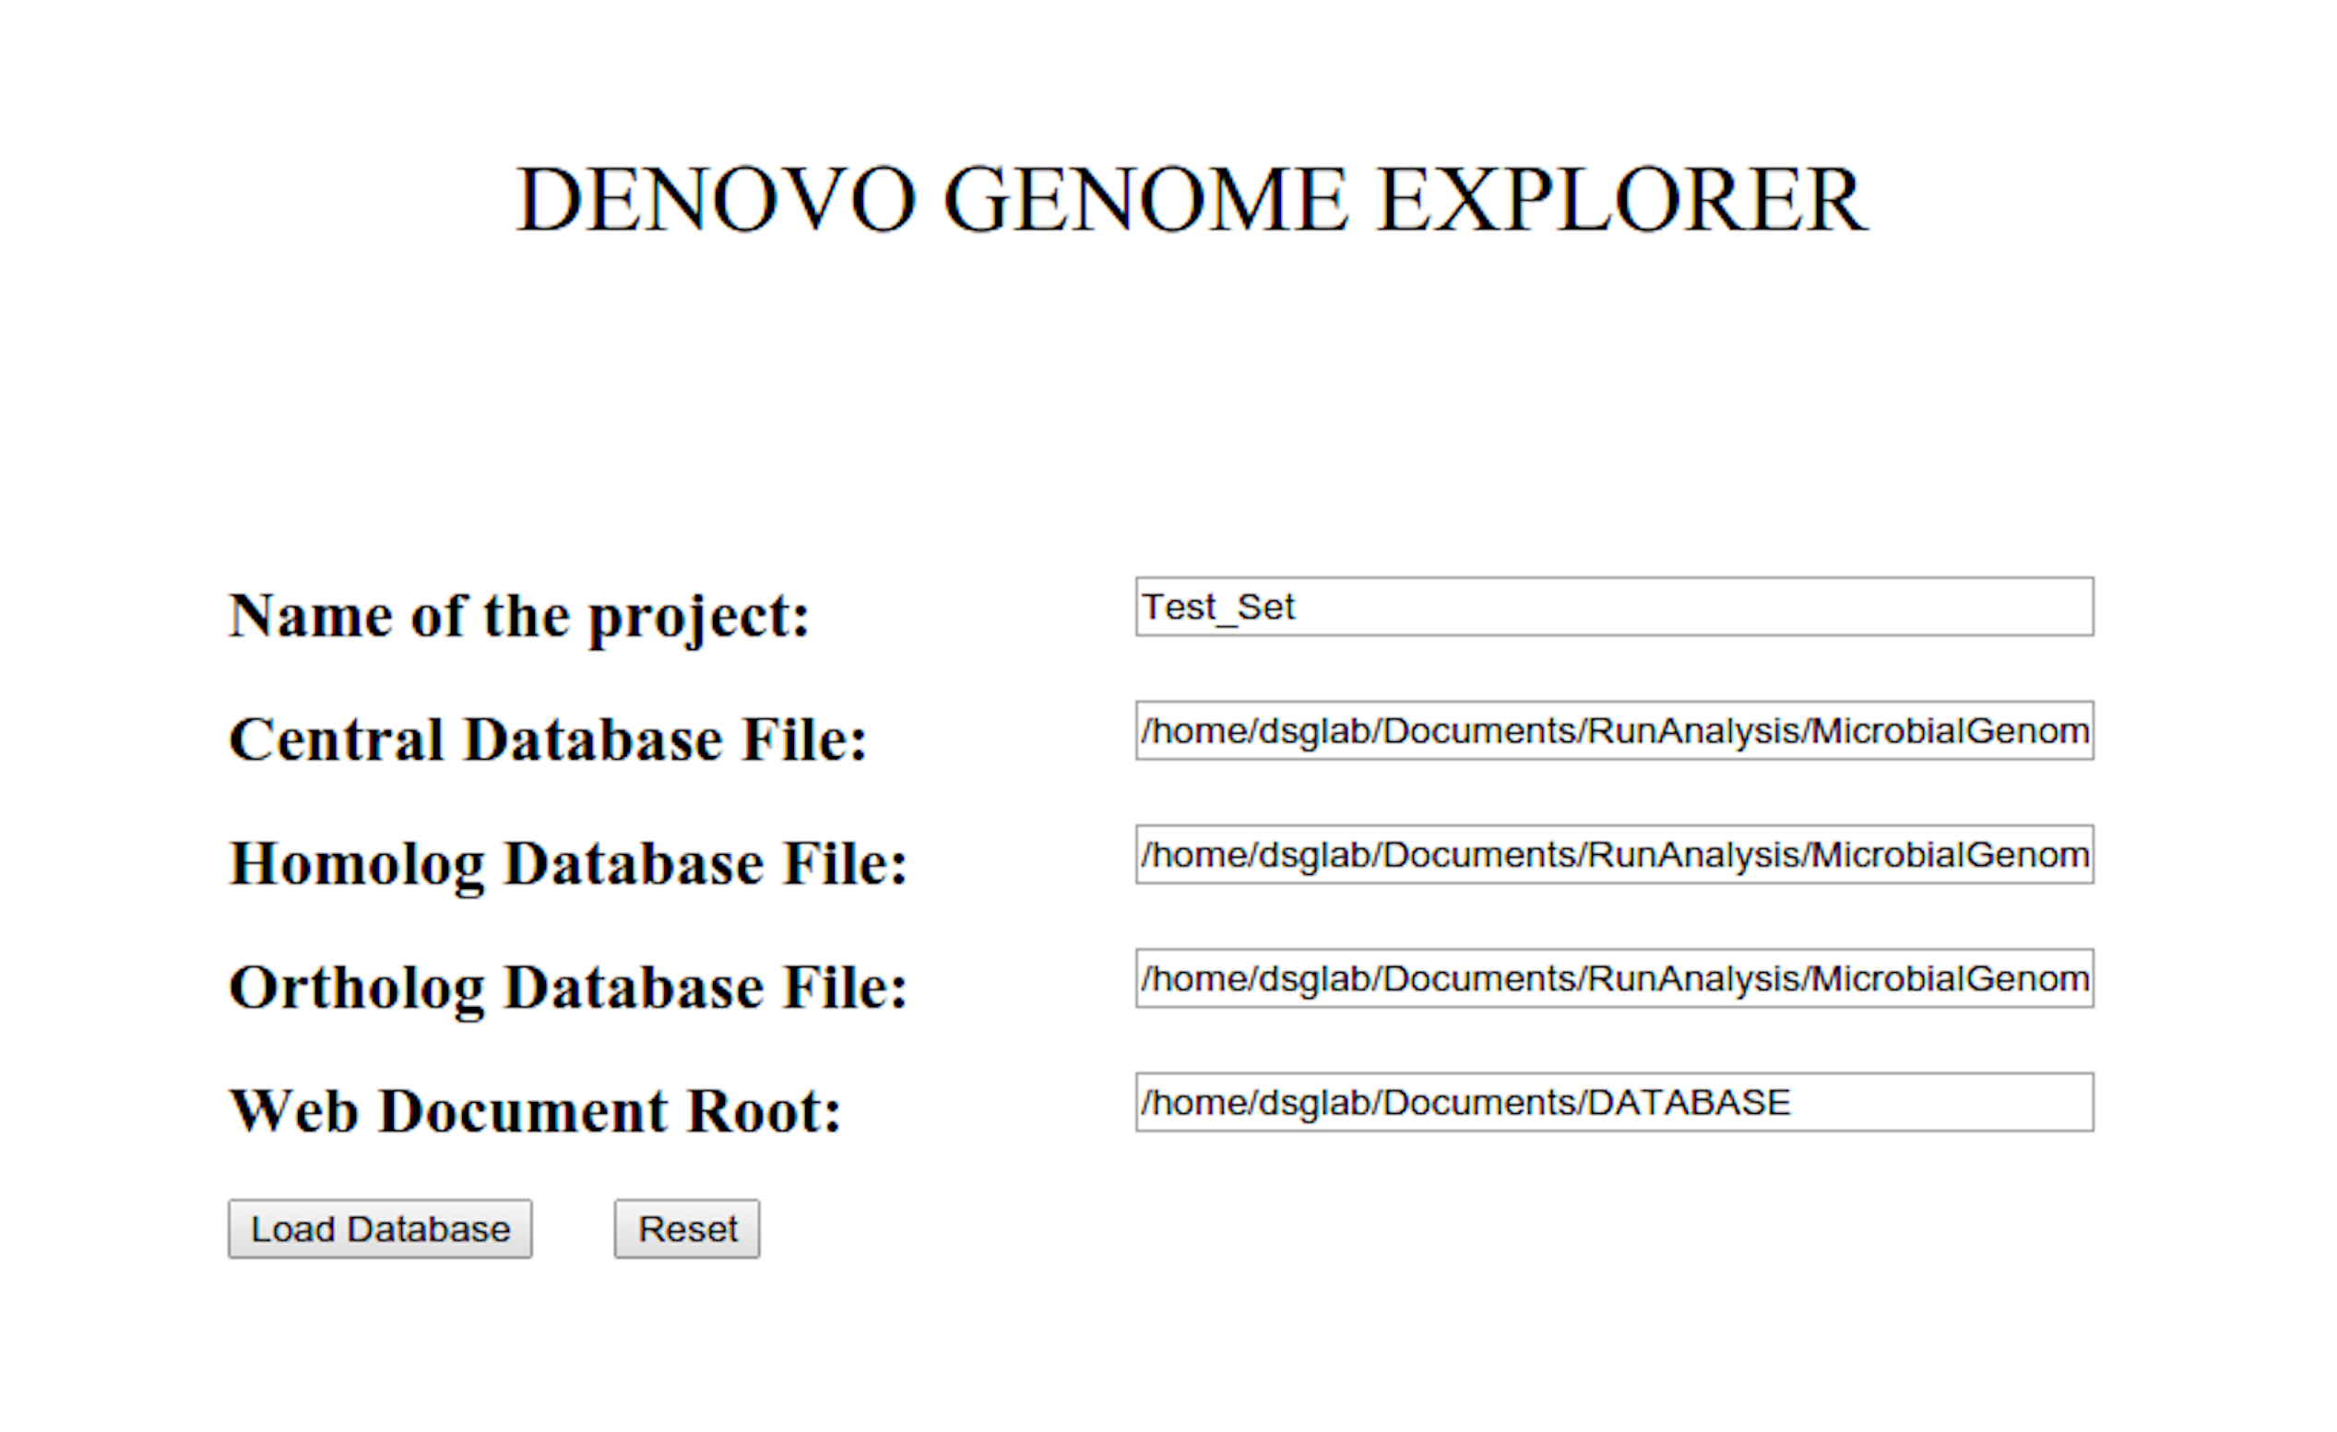

* Enter name of the Project:

TEST_RUN

* Enter full path and name of the Master SQLite database file:

/home/~User_path/DeNoGAP/output/TEST_RUN/test.sqlite

* Enter full path and name of the Homolog SQLite database file:

/home/~User_path/DeNoGAP/output/TEST_RUN/HomologDB File

* Enter full path and name of the Ortholog SQLite database file:

/home/~User_path/DeNoGAP/output/TEST_RUN/OrthologDB File

* Enter full path and name of the Apache Web Document root:

/home/~User_path/Documents/WebRoot

* Click “Load Database”.
* **Analysis Query Interface**

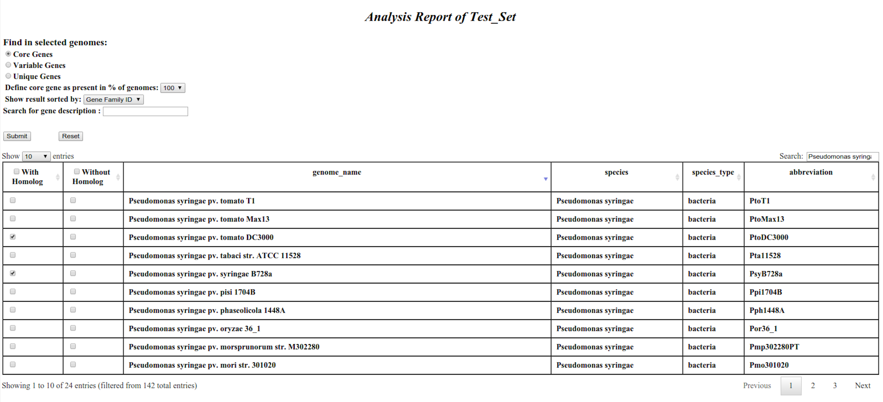

* **Query Options:**
* **Core Genes**: Show core gene families present in selected genomes.
* **Variable Genes**: Show accessory gene families present in selected genomes.
* **Unique Genes**: Show genome-specific families present in selected genomes.
* **Define core gene threshold:** Define percentage cut-off of genomes for predicting core genes.
* **Show result sorted by:** Gene families / Gene ID. (By default: Core genes are sorted by gene families and Variable and Unique genes are sorted by gene id).
* **Search description:** Show results for genes having specific functional description only.
* **Genome Table:**
* **Search:** Filter and display rows containing specific text in any column only.
* **With Homolog:** Select genomes for which homolog should be present.
* **Without Homolog:** Select genomes for which homolog should be absent.
* Click “Submit”.
* Result Table

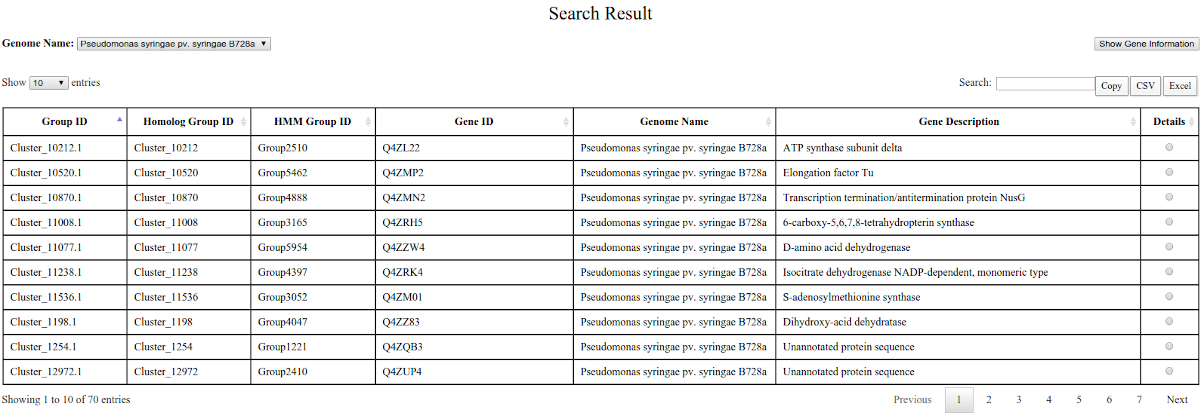

* **Genome Name:** Select genome name to view result for specific genome.
* **Filter row with terms:** Filter and display rows having specific description term only.
* **Group Id:** Display ortholog gene family id
* **Homolog Group Id:** Display homolog family id.
* **HMM Group Id:** Display HMM family id.
* **Gene ID:** Display Locus_tag id for selected genome in each ortholog family.
* **Gene Description:** Show product description for selected Locus tag Id.
* **Detail:** Select Locus tag Id to display detailed information about the gene.
* Click “Show Information” to display detailed information for selected gene Id.
* **Gene Detail Information**

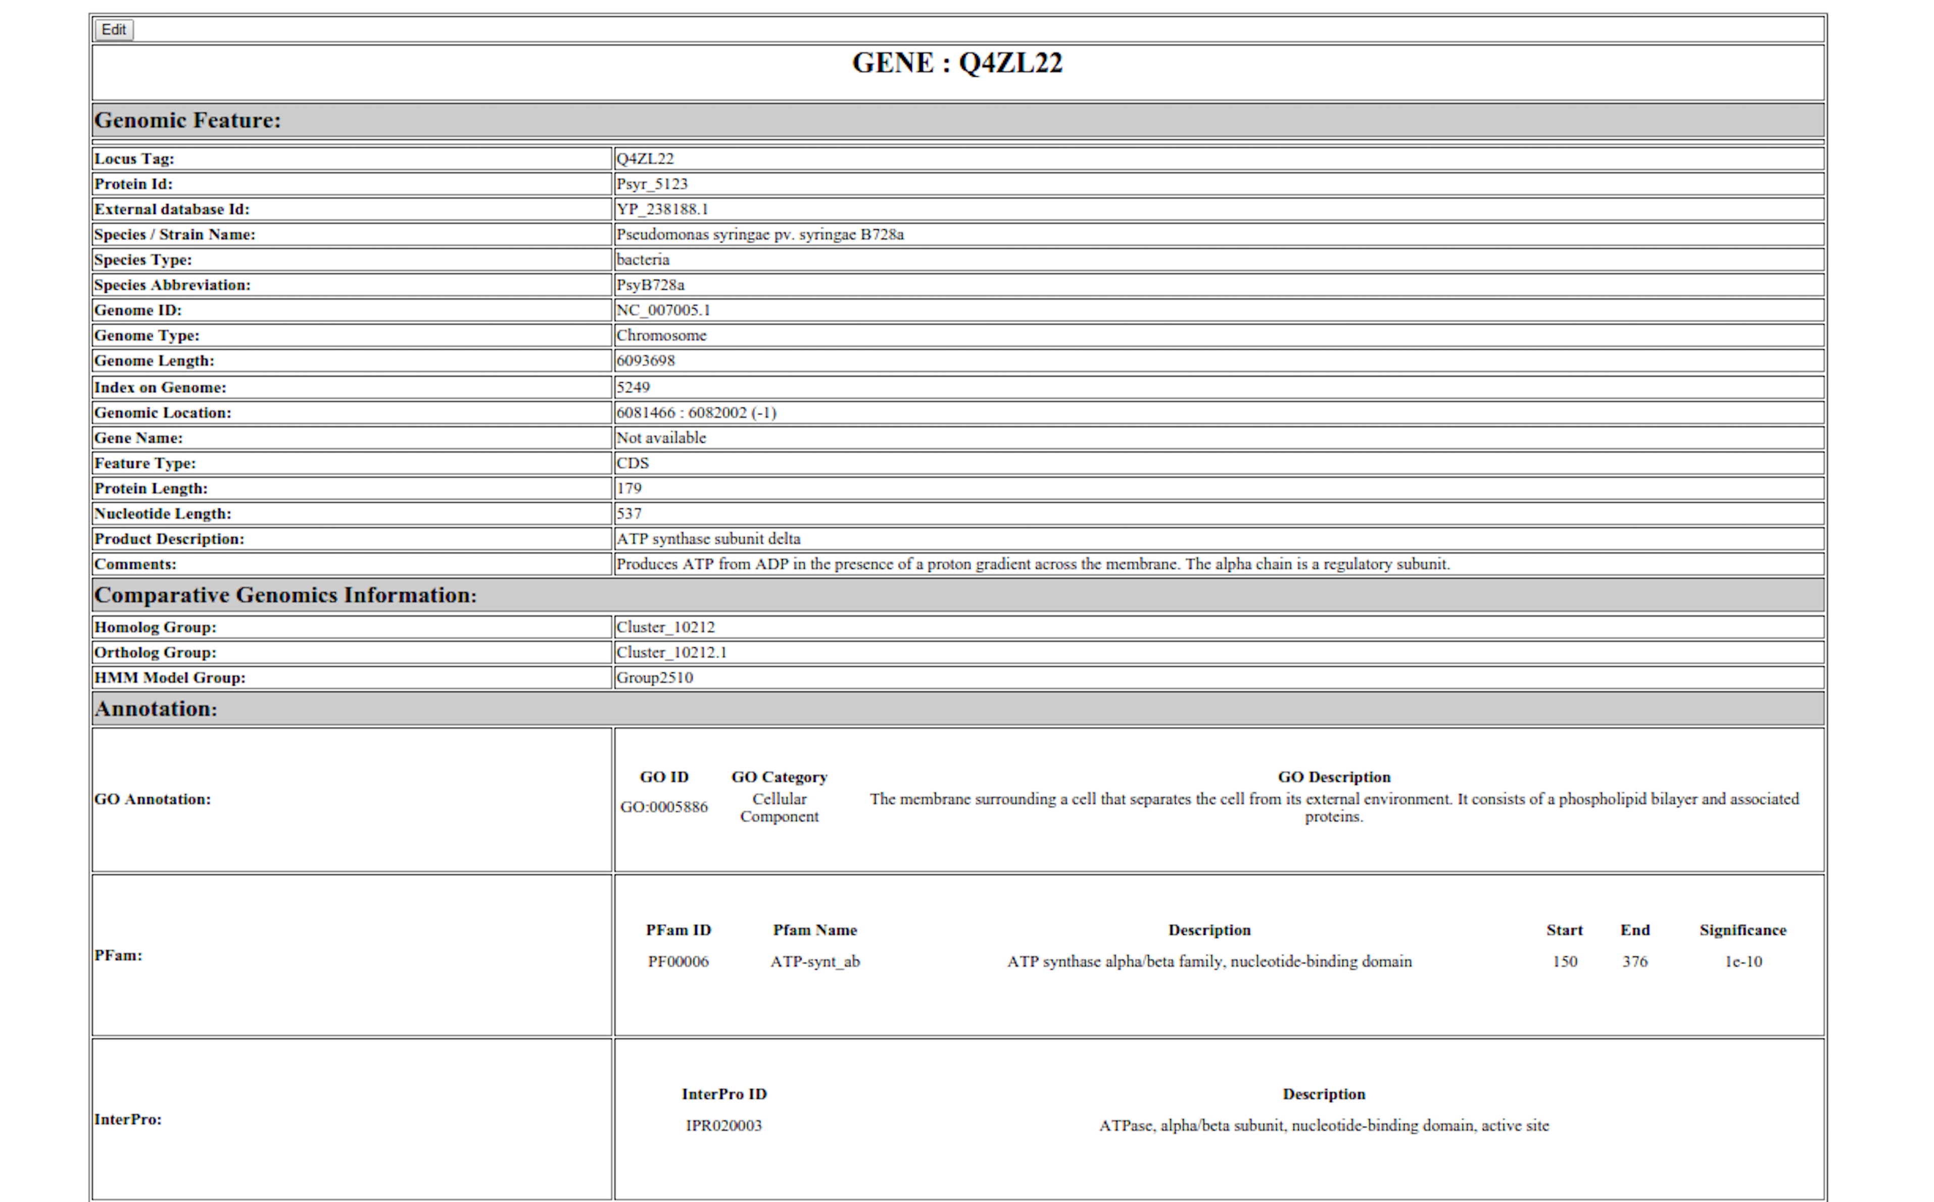

* Click edit button to make changes to the annotation stored in the database for individual gene.
* **Annotation Edit form for selected gene**

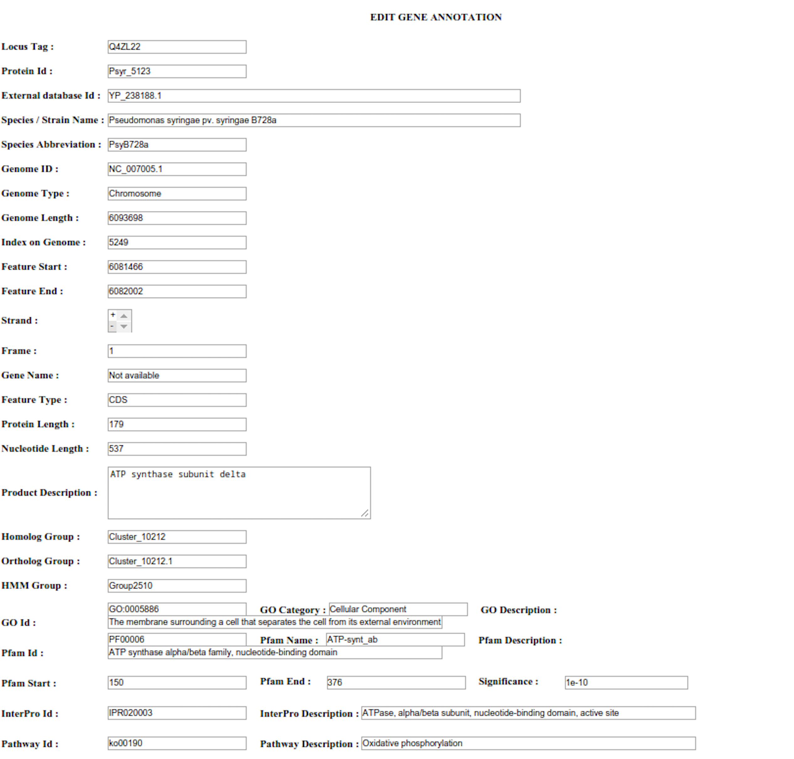

* Click Submit button at the bottom of edit page to store edited information in the database.
* Refresh gene detail information page to display edited information.